


(Approved by AICTE, New Delhi & Affiliated to Andhra University) Pinagadi (Village), Pendurthi (Mandal), Visakhapatnam – 531173

SHORT-TERM INTERNSHIP

By
Council for Skills and Competencies (CSC India)

In association with
ANDHRA PRADESH STATE COUNCIL OF HIGHER EDUCATION (A STATUTORY BODY OF THE GOVERNMENT OF ANDHRA PRADESH) (2026–2027)

PROGRAM BOOK FOR

SHORT-TERM INTERNSHIP

Name of the Student: Mr. LOVA GANESH

Registration Number: 323129510065

Name of the College: Wellfare Institute of Science, Technology and Management
Period of Internship: From: 21-05-2026 To: 21-07-2026 Name & Address of the Internship Host Organization
Council for Skills and Competencies(CSC India)
#54-10-56/2, Isukathota, Visakhapatnam – 530022, Andhra Pradesh, India.

Andhra University
2026

An Internship Report on

STUDENT ACADEMIC PERFORMANCE PREDICTION SYSTEM USING STUDY HOURS, ATTENDANCE, AND LEARNING BEHAVIOR ANALYSIS
Submitted in accordance with the requirement for the degree of

Bachelor of Technology Under the Faculty Guideship of
Mrs.N.Suneetha
Department of CSE

Wellfare Institute of Science, Technology and Management

Submitted by:

Mr. LOVA GANESH

Reg.No: 323129510065
Department of CSE

Department of COMPUTER SCIENCE ENGINEERING
Wellfare Institute of Science, Technology and Management
(Approved by AICTE, New Delhi & Affiliated to Andhra University) Pinagadi (Village), Pendurthi (Mandal), Visakhapatnam – 531173
2026-2027



Instructions to Students

Please read the detailed Guidelines on Internship hosted on the website of AP State Council of Higher Education https://apsche.ap.gov.in

- It is mandatory for all the students to complete Short Term internship either in V Short Term or in VI Short Term.
- Every student should identify the organization for internship in consultation with the College Principal/the authorized person nominated by the Principal.
- Report to the intern organization as per the schedule given by the College. You must make your own arrangements for transportation to reach the organization.
- You should maintain punctuality in attending the internship. Daily attendance is compul- sory.
- You are expected to learn about the organization, policies, procedures, and processes by interacting with the people working in the organization and by consulting the supervisor attached to the interns.
- While you are attending the internship, follow the rules and regulations of the intern organization.
- While in the intern organization, always wear your College Identity Card.
- If your College has a prescribed dress as uniform, wear the uniform daily, as you attend to your assigned duties.
- You will be assigned a Faculty Guide from your College. He/She will be creating a WhatsApp group with your fellow interns. Post your daily activity done and/or any difficulty you encounter during the internship.
- Identify five or more learning objectives in consultation with your Faculty Guide. These learning objectives can address:
  - Data and information you are expected to collect about the organization and/or indus- try.
  - Job skills you are expected to acquire.
  - Development of professional competencies that lead to future career success.
- Practice professional communication skills with team members, co-interns, and your supervisor. This includes expressing thoughts and ideas effectively through oral, written, and non-verbal communication, and utilizing listening skills.
- Be aware of the communication culture in your work environment. Follow up and com- municate regularly with your supervisor to provide updates on your progress with work assignments.

Instructions to Students (contd.)

- Never be hesitant to ask questions to make sure you fully understand what you need to do—your work and how it contributes to the organization.
- Be regular in filling up your Program Book. It shall be filled up in your own handwriting. Add additional sheets wherever necessary.
- At the end of internship, you shall be evaluated by your Supervisor of the intern organiza- tion.
- There shall also be evaluation at the end of the internship by the Faculty Guide and the Principal.
- Do not meddle with the instruments/equipment you work with.
- Ensure that you do not cause any disturbance to the regular activities of the intern organi- zation.
- Be cordial but not too intimate with the employees of the intern organization and your fellow interns.
- You should understand that during the internship program, you are the ambassador of your College, and your behavior during the internship program is of utmost importance.
- If you are involved in any discipline related issues, you will be withdrawn from the internship program immediately and disciplinary action shall be initiated.
- Do not forget to keep up your family pride and prestige of your college.

——— << @ >> ———

Student’s Declaration

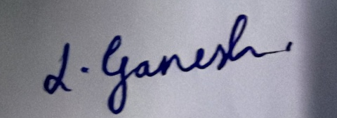
I, Mr. LOVA GANESH, a student of Bachelor of Technology Program, Reg. No. 323129510065 of the Department of Computer Science Engineering do hereby declare that I have completed the mandatory internship from 21-05-2026 to 21-07-2026 at Council for Skills and Competencies (CSC India) under the Faculty Guideship of Mrs.N.Suneetha Department of Computer Science Engineering, Wellfare Institute of Science, Technology and Management.

(Signature and Date)


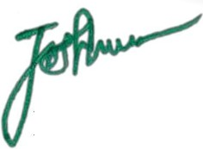

Official Certification

This is to certify that Mr. LOVA GANESH, Reg.No. 323129510009 has completed his/her Internship at the Council for Skills and Competencies (CSC India) on STUDENT ACADEMIC PERFORMANCE PREDICTION SYSTEM USING STUDY HOURS, ATTENDANCE, AND LEARNING BEHAVIOR ANALYSIS under my supervision as a part of partial fulfillment of the requirement for the Degree of Bachelor of Technology in the Department of Computer Science Engineering at Wellfare Institute of Science, Technology and Management.
This is accepted for evaluation.

Endorsements

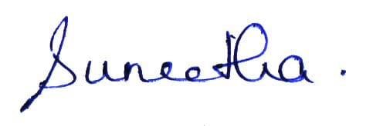
Faculty Guide

Head of the Department


principal

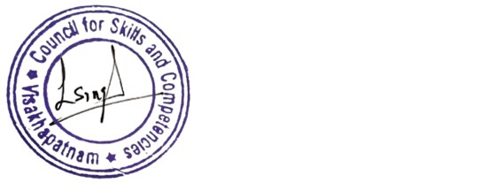

Certificate from Intern Organization

This is to certify that Mr . LOVA GANESH, Reg.No. 323129510065 of Wellfare Institute of Science, Technology and Management, underwent intern- ship in STUDENT ACADEMIC PERFORMANCE PREDICTION SYSTEM USING STUDY HOURS, ATTENDANCE, AND LEARNING BEHAVIOR ANALYSISAnd Sentiment Analysis For Social Media Applications at the Council for Skills and Competencies (CSC India) from 21-05-2026 to 21-07-2026.
The overall performance of the intern during his/her internship is found to be Satis- factory (Satisfactory/Not Satisfactory).

Authorized Signatory with Date and Seal

Acknowledgement

I express my sincere thanks to Dr. A. Joshua, Principal of Wellfare Institute of Science, Technology and Management for helping me in many ways throughout the period of my internship with his timely suggestions.
I sincerely owe my respect and gratitude to Mrs. Nalla Suneetha, Head of the Department of Computer Science Engineering, for his continuous and patient encouragement throughout my internship, which helped me complete this study successfully.
I express my sincere and heartfelt thanks to my faculty guide Mrs.N.Suneetha Assistant Professor of the Department of Computer Science Engineering for his encouragement and valuable support in bringing the present shape of my work.
I express my special thanks to my organization guide Mr. Y. Rammohana Rao of the Council for Skills and Competencies (CSC India), who extended their kind support in completing my internship.
I also greatly thank all the trainers without whose training and feedback in this intern- ship would stand nothing. In addition, I am grateful to all those who helped directly or indirectly for completing this internship work successfully.

